Major Concepts from Ch 1-6
Please answer each question carefully using the lecture slides, textbook, and notes.

1. What studies are found at the bottom of the Quality of Evidence Pyramid? What studies are found at the top? If a close friend recommends a new food or diet based on an article they read, where does this fall on the pyramid? Please Explain.
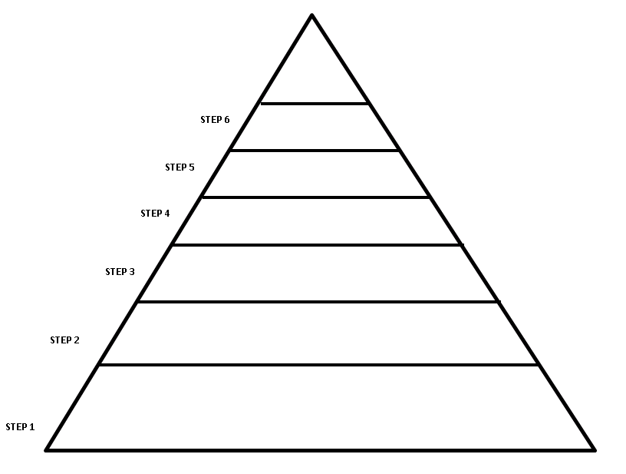

2. Why are SMART goals more successful at changing behavior than general goals?

3. What is the primary function of the digestive system?

4. The primary site of digestion occurs in which organ?

5. Please explain how the following contributes to digestion

- Esophageal Sphincter –

- Microvilli of the Small Intestine –

- Enzymes -

- Stomach acid -

- Sodium bicarbonate –

- Thick mucus layer of the stomach –

- Common Bile Duct of the small intestine –

- Bile Salts -

6. Please describe why this is the major site of digestion and absorption.
What organs are feeding into the small intestine? Please label each
How does each organ contribute to the breakdown of food?

A.)

B.)

C.)

D.)

7. Humans are made up of atoms, molecules, cells, tissues, organs, and organ systems. Please explain how nutrition plays a role at each of these levels of organization:

8. Please list two diseases that have chronic low-grade inflammation

9. Blood glucose must be tightly regulated by hormones to protect the body from tissue damage, coma, and death. Please explain how insulin and glucagon regulate blood sugar.

10. Why are the bran and germ of a whole grain important for a healthy diet? What is wrong with only eating the endosperm in refined grains like white bread?

11.
Healthy Fats: | Unhealthy Fats:
Contribution to inflammation: | Contribution to inflammation:
Food Sources: | Food Sources:

12. HDL and LDL cholesterol impact Cardiovascular Disease. Please explain which is considered “good” and which is considered “bad” and how they impact disease.

13. Why are Omega-3 fats important? Please list three ways to add more to the diet:

14. Your friend is trying to avoid trans fats. She reads the Nutrition Facts panel of a box of crackers that states “0g trans-fat”. Should she eat the crackers? Please explain.

15.
Macronutrients | Monomers | Storage Form | Where is it stored
Carbohydrates
Lipids
Proteins

16. List the functions of Carbohydrates:

17. List the functions of Lipids:

18. List the functions of Proteins:

19. Please draw or describe the process of denaturing a protein. Please explain why it is useful to denature proteins during digestions, but why we would not want to denature our own proteins like enzymes, immune cells, and muscle tissue.

20. List, draw, or describe the pathway of fat digestion from the small intestine to the lymph. Include the digestive secretions that help break down the fat and what happens in the cell of the small intestine to allow it to travel in the circulation.

Family Tree Assignment
Now that you have learned the link between nutrition and chronic disease, find out what your genetic risk factors are. To the best of your ability, trace your lineage back to your great grandparents. Find out what chronic diseases each family member might have. Use this information to create a family tree. This may be provided in a simple list format, hand drawn, or typed. If you do not have access to your full family lineage, do the best you can. The goal is to know what your risks are and what lifestyle changes you can make to promote disease prevention.
- Demonstrate an understanding of nutritional principles in both health & illness
- Describe the relationships between nutrition and human physiology.
- Apply knowledge of nutrition to real-life ex
- Acquire knowledge about the role of Nutrition in disease prevention

